1. So, we learned a lot about schemas and relations.
2. **Agenda**: Let’s practice that a bit.
3. So our goal here now in this exercise is to simply define a schema. Identify the core entities we have in this world and how the schemas for these entities could look like. How they are related and how we could model these relations and then we will just play around with some queries so that we can see how our app and mongodb driver would interact with our database. So, let’s have a look. 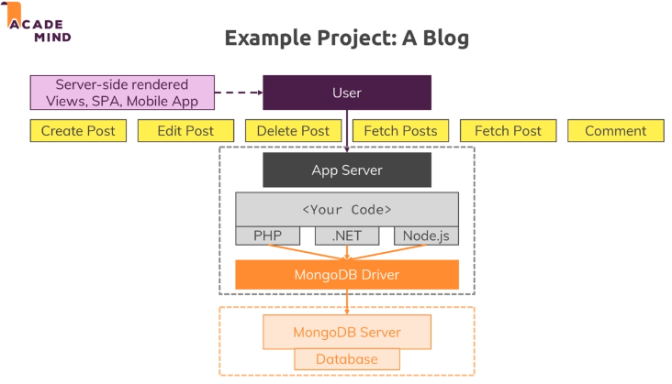
4. There is no single correction solution. But I will go with my approach.
5. So which kinds of data do we have?
   1. User, Post, Comment 🡸 Entities.
6. Now what kinds of data each entity consists of?
   1. _id (hard requirement by mongoDB).  
      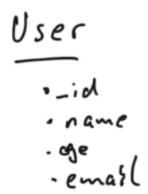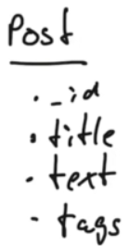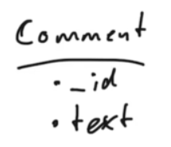
7. How these entities are related with each other? 